|  |  |
| --- | --- |
| |  | | --- | | Key to the histograms:  The histograms show the distribution of log MSEs for each analytic method across 15 versions of each of 5 datasets.  The title of each histogram is: **Histogram of log( tg24.ph2.eval.xx.yy[,z])**  The symbols used for xx, yy and z are as follows:  xx  mi = multiple imputation  rc = regression calibration  bay.mlogit = Bayes logit of posterior mean on P(Y=1) scale  bay.logitm = Bayes posterior mean on logit(P(Y=1)) scale  sim = SIMEX pointwise  sim.coef = SIMEX coefficient-based  yy  bs = B-spline  ps = P-spline  fp = fractional polynomial (of order 2)  z  1 = Dataset 1 (J-shape)  2 = Dataset 2 (linear)  3 = Dataset 3 (threshold with change-point below median and linear increase)  4 = Dataset 4 (threshold with change-point above median and exponential increase)  5 = Dataset 5 (saturation model)  Each page shows 5 histograms, one for each Dataset, analyzed by a specific method | |

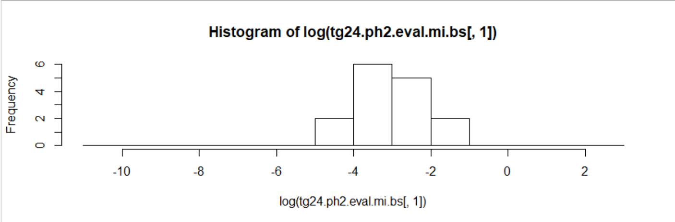

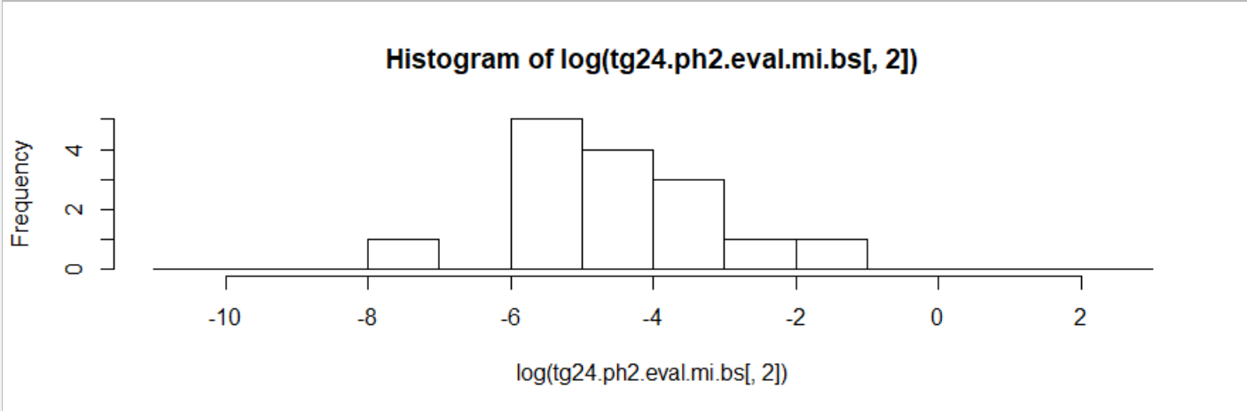

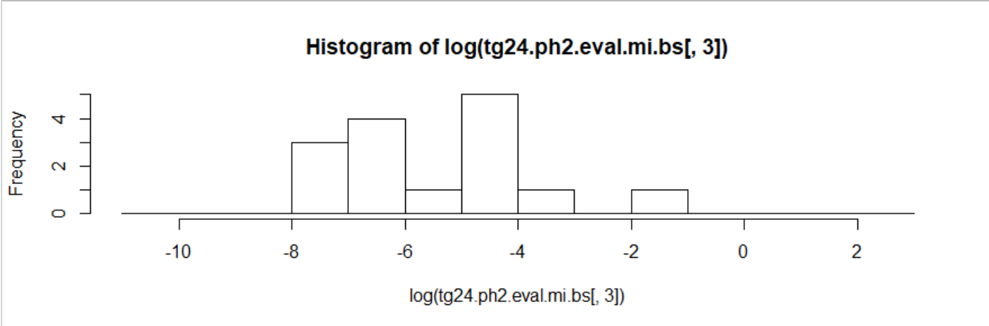

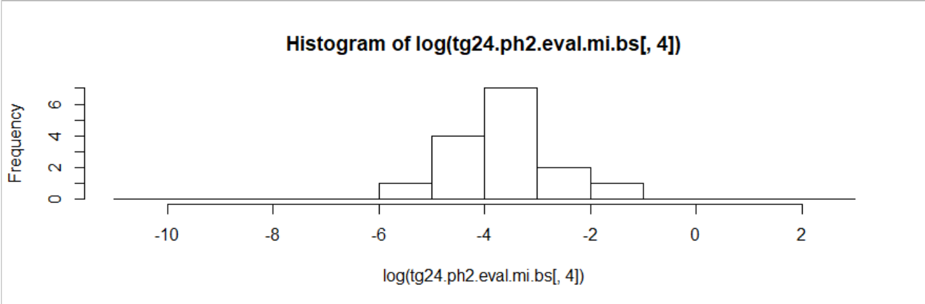

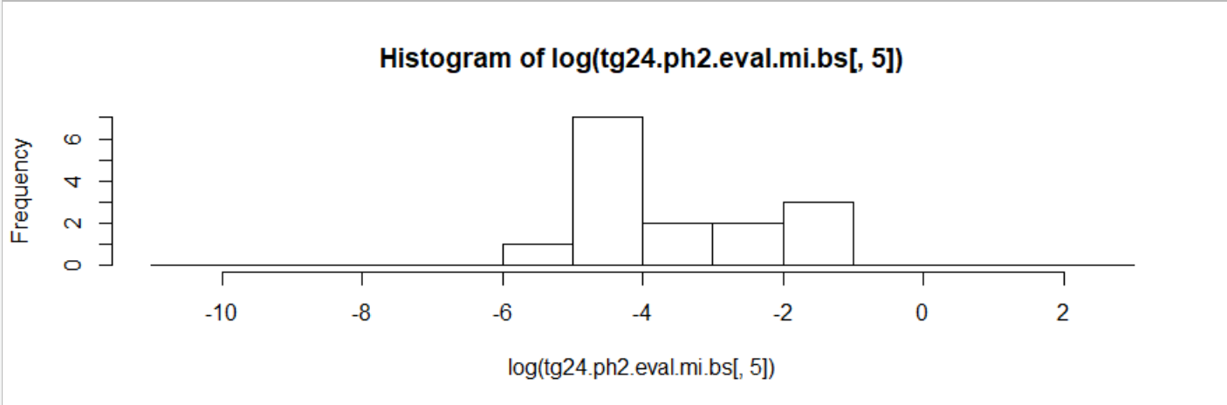**UP TO HERE**

